- Fact table
- Product is canva AI that allows you toi generate things
- Fact_canva_ai_preview needs to accommodate other thifs
- It is like a funnel table
- Currently it tracks lifecycle
- 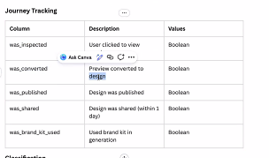
- Future state should be to uplift to include ingredient generation service (another backend service)
- Canva AI uses ingredient generation table
- 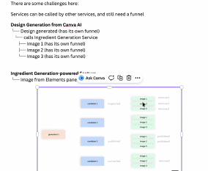
- It has a self parent child table
- He’s looking to split this into multiple tables
- 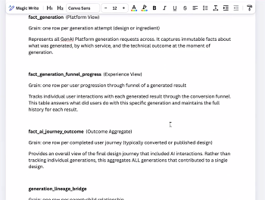
- This is a requirement for a new build
- Ingredients are coming from dynamo db and lands in a table in snowflake
- Looking to remodel the current fact table into multiple tables
- The associated DBT models that are generating the current should be remodelled and moved into Product Exp domain’s dbt project
- Currently: 10 dbt models are used to generate the current table
- Ingredient generation data is 4TB. Would only be interested in a part of that but cannot tell how much of it.
- Need to expand it to cover the ingredients source
- Semantic layer
  - Publish rate analysis
  - Conversion funnel
  - Brand kit usage
  - Generator performance
  - Coverage ratio analysis
  - Discovery impact
  - Multi-touch attribution
  - Jeff assumes 1 semantic view
- Migration
  - We can rebuild, no migration
- Governance
  - no
- Documentation
  - Data model
  - Solution design
- DEV only

